Project Implementation Directorate
Kathmandu Upatyaka Khanepani Limited
Anamnagar, Kathmandu, Nepal

Kathmandu Valley Water Supply Improvement Project, ADB Loan No. 2776

Quarterly Progress Report (October-December, 2018)

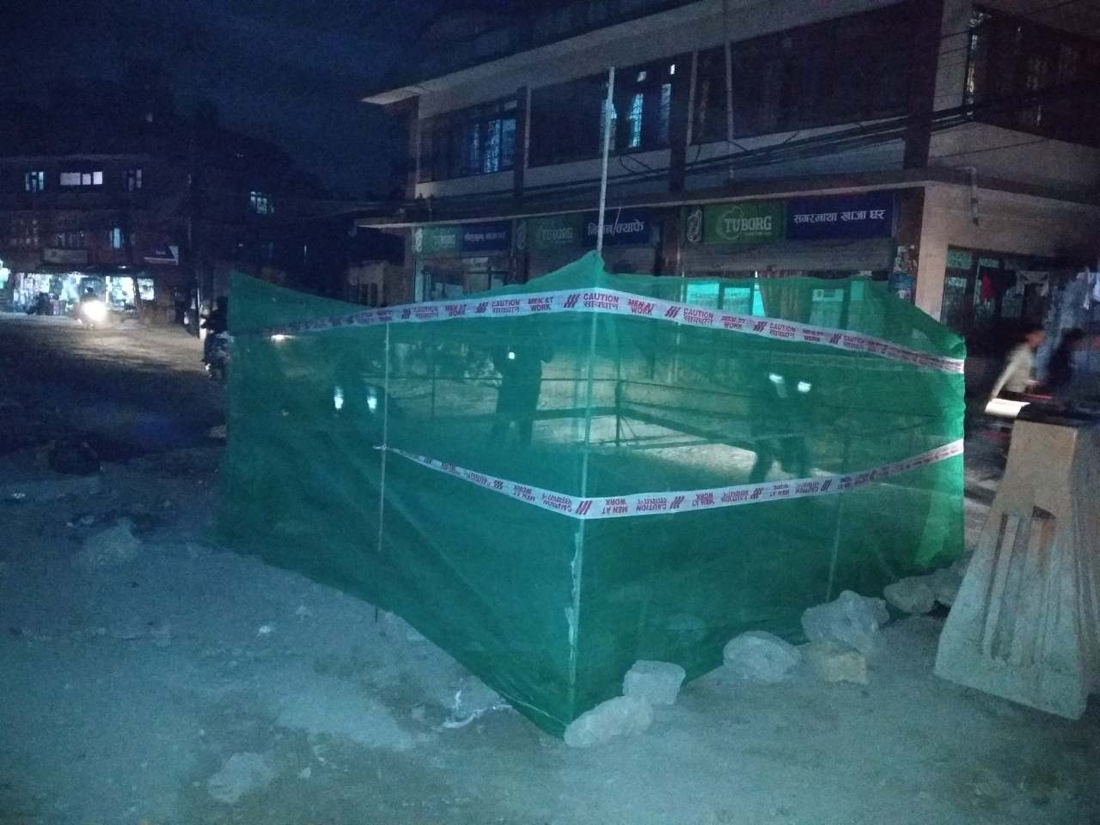

Environmental Monitoring and Safeguard Works
Volume II

Prepared by
Dohwa Engineering Co. Ltd.
In association with the Sub consultants
Environment & Resource Management Consultant (P) Ltd.,
Building Design Authority (P) Ltd. and TAEC Consult (P) Ltd.

January, 2019
This Environmental Monitoring Report is a document of the borrower. The views expressed herein do not necessarily represent those of ADB's Board of Directors, Management, or staff, and may be preliminary in nature. Your attention is directed to the “terms of use” section of this website.
In preparing any country program or strategy, financing any project, or by making any designation of or reference to a particular territory or geographic area in this document, the Asian Development Bank does not intend to make any judgments as to the legal or other status of any territory or area.

Table of Contents
1 Introduction 2
1.1 Background 2
1.2 Loan received from ADB 2
a. Loan 2776 2
2 Institutional framework for Project Environmental Safeguards Compliance 3
3 Service Area and Position of SRT and BDS 4
3.1 Service Area SRT wise 4
3.2 BDS and SRT 4
4 Ongoing Works 5
4.1 Pipe Line Construction 5
4.2 Chambers Construction 5
4.3 Service Reservoir Tank Construction 5
4.4 Household connection 5
4.5 Reinstatement of Municipal Roads-1 5
5 Activities in this Quarter, 2018 6
5.1 ADB Mission 6
5.2 Letter(s)/Memo(s) 6
6 Environment, Safety and Health 7
6.1 Air Pollution Monitoring 7
6.2 Noise Pollution Monitoring 9
6.3 Water Quality and Waste Water Quality monitoring 10
6.4 Chamber Monitoring 12
6.5 SRT Monitoring 13
6.6 Pipeline Monitoring 13
6.7 Occupational health and safety (OHS) 17
6.8 Social Safeguards 18
7 Presentation on Environment, and Social safeguards 18
8 Others related to environment and safety issues 18
9 Grievance Redress 20
9.1 Grievance Redress Mechanism (GRM) 20
9.2 Formation criteria of GRM 21
9.1 Complaints Received during the Reporting Period and their resolution 22
10 Activities Planned for Next Quarter 23
11 Annex: 24
I. Picture log 24
II. Letters and Memos 26
III. OHS Performance Indicator 27
IV. Grievances Records 28

1 Introduction

1.1 Background
The Kathmandu Valley Water Supply Improvement Project (KVWSIP) known as Melamchi Subproject-II is a Government of Nepal's "National Pride Project". It is under implementation of Government of Nepal with the financial assistance of ADB (Loan No 3255-NEP; Loan No 2776-NEP; and Loan-1820), the executing agency for the project Ministry of Water Supply and Sanitation (MWSS) and implementing agency Kathmandu Upatyaka Khanepani Limited, Project Implementation Directorate (PID). The project is ongoing since 2001 to fulfill water supply needs of citizens of Kathmandu Valley. The project is mainly working on establishing several layers of distribution network such as Bulk Distribution System (BDS), Distribution Network Improvement (DNI), District Metering Area (DMA) and Service Reservoir Tank (SRT) and completing previously ongoing projects.
ADB Safeguard Policy Statement 2009 required KVWSIP to develop a structured process of impact assessment, planning and mitigation to address the adverse effects of projects throughout the project cycle. Based on the environmental screening the project was classified as category 'B' project and an Initial Environmental Examination (IEE) was done to examine the proposed infrastructure components for the year 2012-2016 to ensure that it will not damage the environment and provide guidance for planning, construction and operation. In environmental examination, potential environmental impacts are identified, their significance assessed and strategies devised to avoid those impacts or reduce them to the acceptable level. The strategies called mitigation measures are carried forward into Environmental Management Plan (EMP). This EMP assigns responsibilities, timescales and performance indicators/standards for each mitigation measure- to make sure that they are implemented.
As a standard practice for ADB projects, EMP included in the bidding documents and civil contract work packages under the project. EMP implementation is regularly monitored by PID/KUKL and reports are disclosed on the ADB website. The project is under construction and therefore this report presents the environmental monitoring for the month of August 2017 which is in accordance with the ADB's Safeguard Policy Statement 2009.

1.2 Loan received from ADB

a. Loan 2776
On16 September 2011, ADB approved loan2776-NEP for of $80 million, mainly towards improvement of water supply, storage and distribution system including improvement of efficiency, service delivery, institutional development and governance in the water sector in Kathmandu Valley.
The project Area under Kathmandu Valley Water Supply & Sanitation Project (Melamchi Water Supply Project- Subproject 2) under ADB Loan 2776 lies in DNI Packages 1, 2 and 3 and BDS Packages 1, 2 and 3.

2 Institutional framework for Project Environmental Safeguards Compliance
In order to streamline the environmental safeguards implementation and monitoring PID has developed the following structure.

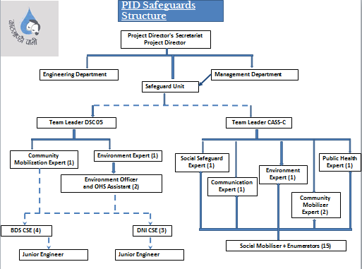

3 Service Area and Position of SRT and BDS

3.1 Service Area SRT wise
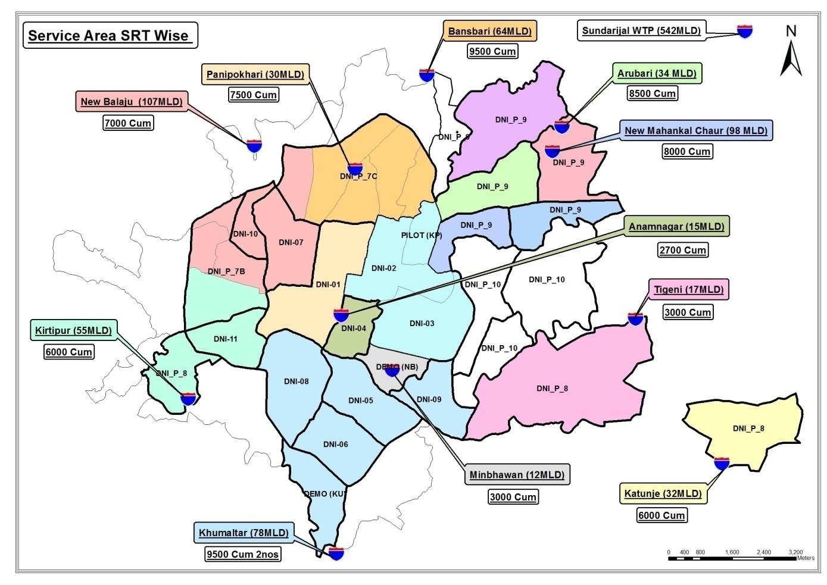

3.2 BDS and SRT

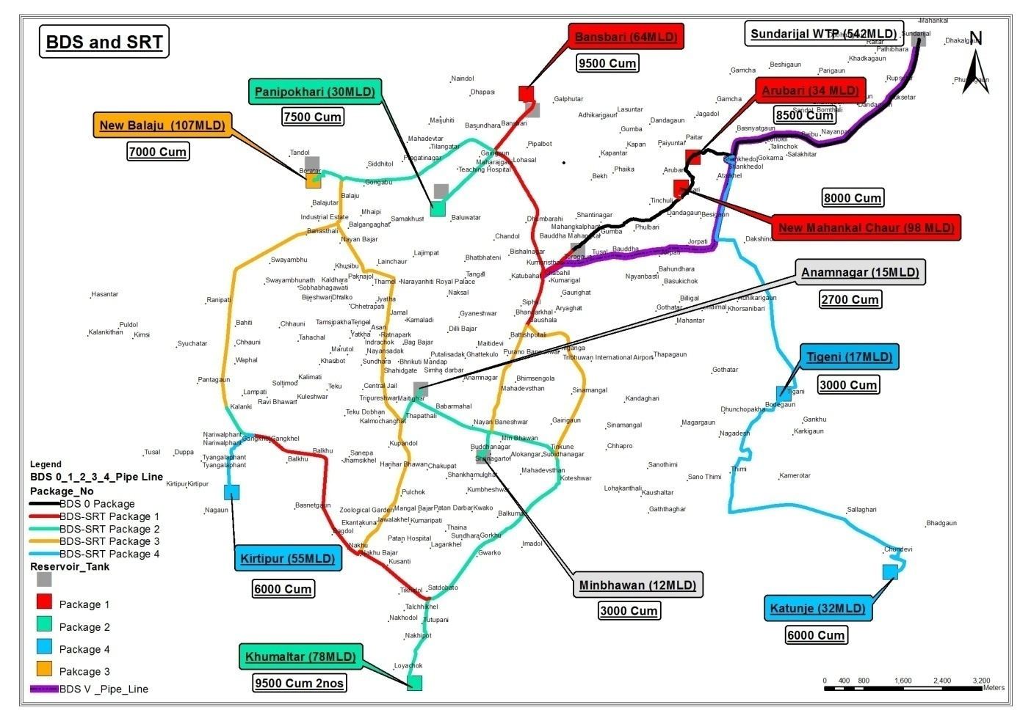

4 Ongoing Works

4.1 Pipe Line Construction
In terms of pipe line connection, 93.89 % for DNI and 93.01% for BDS of pipeline work has been completed. The contract wise update is given in Table 4.1 below.
Table 4.1: Pipe line construction progress in DNI and BDS
Contract No | Progress till this month in % | Contract No | Progress till this month in %
DNI-1 | 86.48 | BDS-1 | 88.93
DNI-2 | 95.43 | BDS-2 | 94.72
DNI-3 | 99.78 | BDS-3 | 95.40
Average progress | 93.89 | Average progress | 93.01

4.2 Chambers Construction
Chambers (Pressure test/Fire hydrant, Bulk Flow Meter, Butterfly Valve/Line Valve/Gate Valve and Press Reducing Valve) were 80.82% for DNI and 84.74% for BDS constructed till this quarter. The contract wise update is given in Table 4.2 below.
Table 4.2: Chamber construction progress in DNI and BDS
Contract No | Progress till this month in % | Contract No | Progress till this month in %
DNI-1 | 68.30 | BDS-1 | 81.54
DNI-2 | 77.69 | BDS-2 | 85.57
DNI-3 | 96.48 | BDS-3 | 87.12
Average progress | 80.82 | Average progress | 84.74

4.3 Service Reservoir Tank Construction
Out of all SRTs 97.41 % works have been completed till this quarter. The contract wise update is given in Table 4.3 below.
Table 4.3: SRT construction progress
Contract No | Progress till this month in %
BDS-1 | 96.13
BDS-2 | 98.12
BDS-3 | 98
Average progress | 97.41

4.4 Household connection
Out of all household connections 80.96 % works have been completed till this quarter. The contract wise update is given in Table 4.4 below.
Table 4.4: Household connection progress
Contract No | Progress till this month in %
DNI-1 | 73.57
DNI-2 | 69.36
DNI-3 | 99.96
Average progress | 80.96

4.5 Reinstatement of Municipal Roads-1
24.49 % works have been completed till this quarter.

5 Activities in this Quarter, 2018

5.1 ADB Mission
There has been no any ADB mission in this quarter.

5.2 Letter(s)/Memo(s)
Various letters were issued by DSC 05 regarding environment and OHS to contractors instructing them to comply on various topics. Similarly, on the same contractors have been submitting completed checklists to DSC 05 via letter. Copies of all letters are attached in annex.
5th October: Submission of Drinking Water Test Report, Safeguard Toolbox Meeting Report, OHS Performance Indicator, Housekeeping Checklist and monthly MRM submitted by DNI Package 1.
9th October: Compensation due to loss of crops for Arubari SRT at Jagdol.
9th October: Submission of bimonthly Safety Toolbox Talk Record, bimonthly Site Housekeeping Checklist Record, Minutes of MRM and Laboratory Test Report of Jar Water submitted by BDS Package 3.
25th October: EHS Documents submitted by BDS Package 1.
1st November: Regarding Safeguards at work spots of DNI Package 1.
1st November: Regarding Safeguards at work spots of DNI Package2.
1st November: Drinking Water Test report DNI Package 1.
1st November: Drinking Water Test report BDS Package 3.
21st November: Submission of Terms of Reference (TOR) of DNI 9a-1.
5th November: Immediate correction of safeguards at work spots.
6th November: Submission of Safeguard Toolbox Meeting report, monthly MRM, Monthly OHS Performance Indicator, Bimonthly Site Housekeeping Checklist, First aid record report, Incident FIR, Drinking water test report by DNI Package 1.
12thNovember: Submission of monthly OHS Performance Indicator by BDS Package 3.
14th November: Submission of EHS Documents by BDS Package 1.
16th November: Submission of Toolbox Talk Report and Construction site housekeeping checklist by BDS Package 2.
1st November: Submission of OHS Performance Indicator Checklist by BDS Package 1 via mail.
5th November: Submission of OHS Performance Indicator Checklist by DNI Package 2 via mail.
5th November: Submission of OHS Performance Indicator Checklist by BDS Package 2 via mail.
2nd December: Letter sent by PID regarding organization of workshop on Safeguards Compliance.
2nd December: Submission of OHS Performance Indicator, toolbox talk and housekeeping checklist by BDS Package 2.
7th December: Submission of OHS Performance Indicator, Bimonthly Safety Toolbox Talk, Housekeeping Checklist by BDS Package 3.
11th December: Submission of OHS Performance Indicator, Bimonthly Safety Toolbox Talk, Housekeeping Checklist by DNI Package 1.
20th December: Submission of Bimonthly Safety Toolbox Talk, Housekeeping Checklist by BDS Package 2.
26th December: Letter sent by PID regarding Approval of TOR for IEE of Kapan DNI 9A1 from Ministry.
3rd December: Letter sent to all packages inviting the CRs and Safety Officers for workshop on Safeguards Compliance.
5th December: Letter sent to PID regarding commitment to submit TOR of IEE and DDR report for BDS 5 and DNI Package 7B and 7C.
12th December: Letter sent to BDS Package 1 regarding compensation due to loss of crops at Arubari.
12th December: Letter sent to PID regarding approval of provisional sum for crop compensation and hiring of private land.
12th December: Letter sent to BDS Package 1 regarding payment of crop compensation and hire of lands.
14th December: Letter sent to DNI Package 1 regarding non compliance of safeguard works.

6 Environment, Safety and Health

6.1 Air Pollution Monitoring
Background
Air pollution is the human introduction of chemicals, particulate matter, or biological materials that cause harm or discomfort to humans or other living organisms, or damages the environment into the atmosphere. Air pollution causes deaths and respiratory disease. Air pollution is often identified with major stationary sources, but the greatest source of emissions is mobile sources, mainly automobiles. Gases such as carbon dioxide, which contribute to global warming, have gained recognition as pollutants by climate scientists, while they also recognize that carbon dioxide is essential for plant life through photosynthesis.
An air pollutant is known as a substance in the air that can cause harm to living beings and the environment. Pollutants can be in the form of solid particles, liquid droplets, or gases. In addition, they may be natural or man-made.
Air is one of the most vulnerable components of the environment. Activities like quarrying, blasting and excavation, disposal of the spoils, blasting of the rocks and other constructional activities within the project area seriously deteriorate the air quality. Furthermore, emission from increased number of vehicles, re-suspension of the road dust by fleeting vehicles, operation of the various types of power generating equipments all contribute to the increase of air pollution within the project area. Similarly, the increase in human population is also responsible to some extent for the increased air pollution. Vehicular and mass activity increases the particles of dust and emission of unwanted gases into the atmosphere which has direct impact on the human health.
Air pollution, in the work area, is measured by using high/ low volume air sampler. The methodology is described precisely.
High and low volume air samplers
High and low volume air samplers are instruments used to collect samples of air particles. The difference between high and low volume air samplers is the amount of air sampled. High volume air samplers typically sample more than 1500 cubic meters (m³) of air over a 24-hour period, while low volume air samplers draw through only 24 m³ of air, or less.
Total suspended particulate matter (TSP)
TSP monitoring measures the total amount of particles suspended in the atmosphere. An instrument called a high volume air sampler is used to collect TSP samples. The high volume air sampler draws a large known volume of air through a pre-weighed filter for 24 hours.
As shown in the diagram below, the sampler filter traps the TSP particles as air passes through the instrument.
After sampling, the filter is re-weighed and the difference in filter weight is the collected particulate matter mass. Dividing the mass by the volume of air sampled gives the concentration of TSP.
Particles less than 10 micrometers in diameter (PM₁₀)
Particle less than 10 µm are especially concerning as these particles can enter the human respiratory system and penetrate deeply into the lungs, causing adverse health effects. Motor vehicles and other combustion processes that burn fossil fuels such as power stations, industrial processes and domestic heaters, generate PM₁₀. Dust storms and smoke particles from bushfires can also be another source of PM₁₀missions.
Instruments used to measure PM₁₀ are either a high or low volume air sampler
The PM₁₀ high or low volume air sampler is similar to that described above for TSP, except that the air sample passes through a size-selective inlet. The inlet removes particles larger than 10µm by using their greater inertia to trap them on a greased plate, while smaller particles pass through the instrument onto the pre-weighed filter.
The diagram of a high volume sampler shows this.
Measuring the volume of air sampled and weighing the filters before and after sampling determines the concentration of PM₁₀ particles in the air.
Ambient air in the project surroundings are not only impacted by the project construction activities but also it is being impacted by the other stakes also. Main causes of the air pollution are heavy traffic, various construction works by the stakeholders and existing road conditions.

Diagram of a PM₁₀ sampler

AP status for the entire contract packages BDS and DNI at their work places by the respective contractors and can be seen in Table 6.1.1.
Table 6.1.1: Air pollution monitoring
Site No. | Date of Testing | Site Location | Date/  Time | Parameters
 |  |  |  | TSPM  µg/m3 | PM₁₀ µg/m³ | PM_{2.5} µg/m³ | SO2 µg/m3 | NO2  µg/m3
Government Standards |  |  |  | 230 | 120 | 40 | 70 | 80
BDS-1 | NA | NA | NA | NA | NA | NA | NA | NA
BDS-2 | NA | NA | NA | NA | NA | NA | NA | NA
BDS-3 | NA | NA | NA | NA | NA | NA | NA | NA
DNI-1 | NA | NA | NA | NA | NA | NA | NA | NA
DNI-2 | NA | NA | NA | NA | NA | NA | NA | NA
DNI-3 | NA | NA | NA | NA | NA | NA | NA | NA

6.2 Noise Pollution Monitoring
Noise is considered as a serious environmental hazard. Noise can be defined as “any sound that is undesirable because it interferes with speech and hearings, is intense enough to damage hearing, or is otherwise annoying”. The definition of noise as unwanted sound implies that it has an adverse effect on human beings and their environment, including infrastructures and domestic animals. Noise pollution affects both health and behavior. Unwanted sound (noise) can damage psychological and physiological health. Noise pollution can cause hypertension, high stress levels, tinnitus; noise induced hearing loss, sleep disturbances, and other harmful effects.
Sound becomes unwanted when it either interferes with normal activities such as irritation from vehicles horns, sleep, conversation, or disrupts or diminishes one's quality of life.
Chronic exposure to noise may cause noise-induced hearing loss. Older males exposed to significant occupational noise demonstrate more significantly reduced hearing sensitivity than their non-exposed peers, though differences in hearing sensitivity decrease with time.
High noise levels can result in cardiovascular effects and exposure to moderately high levels during a single eight-hour period causes a statistical rise in blood pressure of five to ten points and an increase in stress, and vasoconstriction leading to the increased blood pressure noted above, as well as to increased incidence of coronary artery disease.
During the construction of any developmental project, activities like blasting, drilling and vehicular movement, power tool operation may generate unacceptable noise levels that may seriously deteriorate the environment and may cause detrimental impacts on human beings and other ecological components.
As per the National Ambient Sound Quality Standards the sound level is to maintained 75 dB(A) for the day time and 70 dB(A) in the night time which is mentioned in Table 6.2.1 is taken as the noise level as the works are carried at construction sites.
Table 6.2.1: National Ambient Sound Quality Standards of Nepal-2012
S.N. | Area | Noise Level dB(A)
 |  | Day time | Night time
1 | Industrial Area | 75 | 70
2 | Commercial Area | 65 | 55
3 | Urban Residential Area | 55 | 50
4 | Rural Residential Area | 45 | 40
5 | Mixed Residential Area | 63 | 55
6 | Peace Area | 50 | 40
Sound level is measured by using precise decibel sound meter at all the sites.
Noise Pollution monitoring has not been done by the contractor in this quarter. Report of noise monitoring done by consultant is in table 6.2.2.
Table 6.2.2: Noise Pollution monitoring
Contract Pkg | Date and time |  |  | Site Location |  |  | LA_{eq} (dBA) |  |  |  |  |  | Condition
 | O | N | D | O | N | D | Day Time |  |  | Night Time
 |  |  |  |  |  |  | O | N | D | O | N | D
Government standards |  |  |  |  |  |  | 75 | 75 | 75 | 70 | 70 | 70 | Industrial area (for Construction site)
Monitoring by Contractors
All Packages | NA | NA | NA | NA | NA | NA | NA | NA | NA | - | - | - | -
NR=Not recorded, NA=Not available, TBA= To Be Available

6.3 Water Quality and Waste Water Quality monitoring
Water is one of the most important components of the environment and can be deteriorate through various anthropogenic activities. Therefore, it is necessary to utilize manifold evaluation of water quality characteristics in order to develop a total evaluation of existing water quality as well as micro scale changes that result from project activities in the water bodies. Any construction activity at the upstream or downstream of a River and nearby water sources degrades the water quality.
The EMP team has fixed their camp locations for water sampling. The samples were collected in disinfected pet bottles and tested in the laboratory as per the IEE requirement for drinking water and waste water coming to the inland water from the contractor's camps.
Contractor from DNI Package 1, BDS-2 had done Water Quality monitoring in the month October in this quarter. The water quality test report shows that the inspected jar water were found to be unsafe for drinking to which DSC has instructed the contractor to stop using that brand of Jar Water. Similarly the contractors have also acknowledged our instruction and have stopped using New Aqua MSK, REEF water and Aqua SV. The water quality and waste water quality monitoring in this quarter and is shown in Table 6.3.1.
Table 6.3.1: Water quality monitoring at various sites

Parameters | Units | WHO GV | NDWQS | DNI Pkg 1  Aqua 2N | DNI Pkg 1  Aqua cool | DNI Pkg 1  New Aqua MSK | BDS 3  jar water (REEF) | BDS 3  Jar Water (Aqua SV, Manamaiju, Ktm) | Other all Packages
Color | Hazen | 15 | 5(15) | <0.05 | <0.05 | <0.05 | <0.05 | <0.05 | -
Turbidity | NTU | 5 | 5 (10) | <1 | <1 | 10.4 | <1 | <1 | -
Total Dissolved Solids | mg/l | 1000 | 1000 | 89 | 97.4 | 9.5 | 13.4 | 13 | -
Conductivity | µS/cm | - | 1500 | 138.6 | 150.7 | 15.23 | 21.4 | 20.2 | -
Taste | TFN | - | Not Objectionable | N.O | N.O | N.O | N.O | N.O | -
Odour | TON | - | Not Objectionable | N.O. | N.O. | N.O | N.O | N.O | -
pH | - | 6.5 - 8.5 | 6.5-8.5* | 7.4 | 7.1 | 6.1 | 5.6 | 5.5 | -
Total Hardness | mg/l as CaCO₃ | 500 | 500 | <1 | 44 | <1 | <1 | <1 | -
Calcium | mg/l | - | 200 | <0.5 | 8 | <0.5 | <0.5 | <0.5 | -
Chloride | mg/l | 250 | 250 | <0.5 | 15.99 | <0.5 | <0.5 | <0.5 | -
Ammonia | mg/l | 1.5 | 1.5 | 0.22 | <0.05 | <0.05 | 0.27 | 0.29 | -
magnesium | mg/l |  | 200 | <0.5 | 5.83 | <0.5 | <0.5 | <0.5 | -
Iron | mg/l | 0.3 | 0.3 (3) | 0.09 | <0.05 | <0.05 | 0.08 | <0.05 | -
Arsenic | mg/l | 0.01 | 0.05 | <0.01 | <0.01 | <0.01 | <0.01 | <0.01 | -
Copper | mg/l | 2 | 1 | 0.011 | <0.01 | <0.01 | <0.01 | <0.01 | -
Nitrate | mg/l | 50 | 50 | 0.61 | 3.4 | 0.97 | 1.29 | 2.21 | -
Aluminum | mg/l | - | 0.2 | <0.01 | <0.01 | <0.01 | <0.01 | <0.01 | -
Cyanide | mg/l | - | - | - | - | - | - | - | -
Mercury | mg/l | 0.001 | 0.001 | <0.001 | <0.001 | <0.001 | <0.001 | <0.001 | -
Cadmium | mg/l | 0.003 | 0.003 | <0.002 | <0.002 | <0.002 | <0.002 | <0.002 | -
Lead | mg/l | 0.01 | 0.01 | <0.01 | <0.01 | <0.01 | <0.01 | <0.01 | -
Free Residual Chlorine | mg/l | 0.5 | 0.1-0.2* | - | - | - | - | - | -
Chromium | mg/l | 0.05 | 0.05 | <0.02 | 0.03 | <0.02 | <0.02 | <0.02 | -
Sulfate | mg/l | - | 250 | 12.66 | 12.48 | 4.23 | 12.1 | 6.82 | -
Manganese | mg/l | 0.4 | 0.2 | <0.05 | <0.05 | <0.05 | <0.05 | <0.05 | -
Zinc | mg/l | - | 3 | 0.015 | <0.01 | <0.01 | 0.015 | 0.015 | -
Fluoride | mg/l | 1.5 | 0.5-1.5* | 0.06 | 0.2 | <0.01 | 0.08 | 0.08 | -
Resudial Chlorine | mg/l |  | 0.1-0.2 | <0.1 | <0.1 | <0.1 | <0.1 | <0.1 | -
Total Coli forms | CFU/ 100ml | Nil | Nil | Nil | Nil | Nil | 11 | Nil | -
E. Coli | CFU/ 100ml | Nil | Nil | Nil | Nil | Nil | 34 | Nil | -
Table 6.3.2: Waste Water Quality Monitoring
Site No. | Date of Sampling | Site Location | Parameters (Government Standards)
 |  |  | pH | Conductivity µS/cm | BOD mg/L | TSS mg/L | TN mg/L | TP mg/L
All sites |  |  | 5.5-9.0 | - | 50 | 50 | - | -
All Packages | NA | NA | NA | NA | NA | NA | NA | NA
Reinstatement of Municipal Road-1 | NA | NA | NA | NA | NA | NA | NA | NA

6.4 Chamber Monitoring
It was decided that monitoring will be done not only of sites where pipes are laid but also of chambers and SRTs constructed at various sites. Following are the key activities for standard safeguards compliance for chambers construction and compliance status for this month is presented in the Table 6.4.1. Contractors have not given due care about safety, health and environmental issues at the sites where the works are in progress. Many gaps are seen on sites which need to address by the contractors. Following are the necessary matters to comply by them;
- Chamber needs to be barricaded using green nets/Zinc sheets all around the chamber.
- The green net/Zinc sheet needs to be placed using metal posts both vertically and horizontally so that no any vehicles can fall inside the trench. Green nets/Zinc sheets to be placed inside the metal poles.
- Reflective tape needs to be pasted all around the chamber to make it visible at night.
- Road diversion board and information board needs to be place beside the chamber.
- There should not be any excess material (soils, gravels, construction materials) outside the green net.
- Shoring has to be installed during chamber construction.
- All the safeguard measures mentioned above needs to be complied until the trench section is reinstated and cleaned.
Monitoring of interconnection, pressure tests are also included nature of safeguards issues are same as of the chambers.

Table 6.4.1: Compliance Monitoring Results of Chambers construction
S N | Date | Location | Package | Achieved score % | _{Compliance status}
1 | 01-10-18 | Balkhu | BDS Package 2 | 33.75 | _{Very Poor}
2 | 01-10-18 | Balkhu | BDS Package 2 | 49.15 | _{Very Poor}
3 | 01-10-18 | Chapagaun Dobato | DNI Package 1 | 47.46 | _{Very Poor}
4 | 08-10-18 | Tinkune | BDS Package 2 | 16.95 | _{Very Poor}
5 | 08-10-18 | Anamnagar | DNI Package 1 | 100 | _{Excellent}
6 | 11-10-18 | Ratnapark 1 | DNI Package 1 | 83.05 | _{Good}
7 | 29-10-18 | Banganga | DNI Package 2 | 54.24 | _{Poor}
8 | 29-10-18 | Nardevi | DNI Package 2 | 38.98 | _{Very Poor}
9 | 30-10-18 | Ratnapark2 | DNI Package 1 | 77.97 | _{Good}
10 | 30-10-18 | Kesharmahal | DNI Package 1 | 28.81 | _{Very Poor}
11 | 31-10-18 | Anamnagar | DNI Package 1 | 91.53 | _{Excellent}
12 | 30-10-18 | Chabahil 1 | BDS Package 1 | 66.1 | _{Good}
13 | 31-10-18 | Bhadrakali | BDS Package 1 | 50.85 | _{Poor}
14 | 31-10-18 | Existing Mahankal | BDS Package 1 | 57.63 | _{Poor}
15 | 31-10-18 | Chabahil 2 | BDS Package 1 | 66.1 | _{Good}
16 | 12-11-18 | Ratnapark | DNI Package 1 | 83.05 | _{Good}
17 | 14-11-18 | Bhadrakali | BDS Package 3 | 47.46 | _{Very Poor}
18 | 15-11-18 | Mahankal | BDS Package 1 | 41.3 | _{Very Poor}
19 | 17-11-18 | Chabahil | BDS Package 1 | 42.37 | _{Very Poor}
20 | 21-11-18 | Sinamangal | DNI Package 2 | 93.22 | _{Excellent}
21 | 21-11-18 | NarayangopalChowk | BDS Package 1 | 38.98 | _{Very Poor}
22 | 22-11-18 | Ratnapark | DNI Package 1 | 83.05 | _{Good}
23 | 24-11-18 | Bagbazar | DNI Package 1 | 49.15 | _{Very Poor}
24 | 30-11-18 | Gwarko | DNI Package 2 | 25.42 | _{Very Poor}
25 | 25-12-18 | Maitighar | BDS 2 | 54.2 | _{Poor}
26 | 25-12-18 | Bhadrakali | BDS 3 | 76.3 | _{Good}
Out of 26 site monitoring, 10 achieved over 60% compliance. It was observed that most of the sites lacked information boards, the green nets that were not supported by both horizontal and vertical metal posts were corrected during joint site visit.

6.5 SRT Monitoring
Out of 1 SRT site monitoring it was found that all sites achieved above 75% compliance. It was observed that first aid boxes are now seen to have been placed with contents as per Nepal Red Cross Society's standard. Similarly, SRT sites have started to display emergency contact persons list and emergency plan. Table 6.5.1 shows the compliance status of SRT. A separate checklist for scaffolds and accommodation has been filled at all SRT sites as well.
Table 6.5.1: Compliance Monitoring Status of SRT
S N | Date | Location | Name of contractor | Package | Achieved score % | Compliance status
1 | 1-10-2018 | Khumaltar | JWIL-SCPL JV | BDS 2 | 76.5 | Good

6.6 Pipeline Monitoring
The average scores of pipeline monitoring regarding environmental and concerns are shown in Table 6.6.1 and 6.6.2.

Table 6.6.1: Compliance Monitoring Status of Pipelines
S N | Date | Location | Name of contractor | Package | Achieved score % | Compliance status
1 | 29-10-18 | Patan | Hangzhou-Sharma JV | DNI 2 | 60.14 | Good
2 | 29-10-18 | Basantapur | Hangzhou-Kalika JV | DNI 1 | 72.12 | Good
3 | 29-10-18 | Anamnagar | Hangzhou-Kalika JV | DNI 1 | 59.65 | Poor
4 | 22-11-18 | Basantapur | Hangzhou-Kalika JV | DNI 1 | 75 | Good
5 | 22-11-18 | Newroad | Hangzhou-Kalika JV | DNI 1 | 43.5 | Poor
6 | 26-11-18 | Naxal | Hangzhou-Kalika JV | DNI 1 | 44.59 | Poor
7 | 26-11-18 | Kamalpokhari | Hangzhou-Kalika JV | DNI 1 | 78.57 | Good
8 | 25-12-18 | New Road | Hangzhou-Kalika JV | DNI 1 | 57.9 | Poor
9 | 27-12-18 | Patan | Hangzhou Sharma JV | DNI 2 | 54.6 | Poor
10 | 30-12-18 | Gwarko | Hangzhou-Kalika JV | DNI 1 | 68.1 | Good
A total of 10 sites were monitored for pipe laying, out of 10, 5 sites achieved above 60% compliance and 5 out of 10 achieved below 60% compliance. The detailed average score is presented in table 6.6.2.
Table 6.6.2: Average score of checklist
Kathmandu Valley Water Supply Improvement Project
Project Implementation Directorate, Kathmandu Upatyaka Khanepani Limited
Name of Work:
Name of Contractor:
Contract No: |  |  | Monitoring Date
 |  |  | Time
Place:
SN | Subject | Activities | Yes | No | Full Score | Achieved Score | Remarks
 |  |  | √ | X
1 | Signage | Available Sign Board with the Name of Project & Contractor |  |  | 3 | 2.4 | Satisfactory
 |  | Available Visible Sign Board for Traffic Alternative Route |  |  | 2 | 1.8 | Satisfactory
2 | Health & Safety | Available of authorized representative of contractor at work site (Engineer/Supervisor) |  |  | 3 | 3 | Satisfactory
 |  | Regular visit of work area for supervision by contractor's Safety supervisor |  |  | 3 | 2.25 | Satisfactory
 |  | Hard Barricading for Working Area: Minimum 4 ft. height Metal posts with Nylon Ropes/Green net in 3 rows for BDS/DNI works and danger light (for night work) on Non-Black topped Roads (Primary line) |  |  | 4 |  | No primary line work
 |  | Metal hoarding/Sheet fence (Safety Barrier) for BDS & DNI Primary line works on Black topped Roads Available |  |  | 4 |  | No primary line work
 |  | Hard Barricading for Working Area: Minimum 4 ft. height Metal posts with Nylon Ropes in 3 rows for DNI works on Non-Black topped/Black topped Roads Available |  |  | 4 | 1.83 | Satisfactory
 |  | Entry of Non-Authorized Person inside the area of Safety Barriers |  |  | 3 | 1.2 | Satisfactory
 |  | Trench Shoring for BDS & DNI Primary line Available |  |  | 4 |  | Not many Primary lines
 |  | Use of Personnel Protective Equipments (PPEs) by Workers i.e. hard helmets, PPE vest, Gloves, Safety Glasses, Boots, Masks etc and mention in remarks the % of use and which PPEs is not used. |  |  | 7 | 5.1 | Satisfactory
 |  | Grant of Permission for entry inside the work areas with safety barrier to the site engineer and other construction personnel without the use of PPEs such as Hard helmets and Reflector Jacket. |  |  | 2 | 0.9 | Satisfactory
 |  | First Aid Box at Working Area Available |  |  | 4 | 1.65 | Satisfactory
 |  | Drinking Water at Working area Available |  |  | 2 | 1.6 | Satisfactory
3 | Grievances Redress Mechanism | Help Desk: Table, Chair and First Aid with Grievance Register Available visible by Public |  |  | 3 | 1.75 | Satisfactory. In most places the supervisor carries the first aid and grievance register in his bag
 |  | Helper at Help Desk Available |  |  | 2 | 0.7 | Not Satisfactory
4 | Traffic and Pedestrians Access without obstruction and Housekeeping of work area | Cross over metal platforms on trench of BDS & DNI Pipeline work Available |  |  | 3 | 1.31 | Usually alternative to metal platforms are used.
 |  | Availability of platforms on loose soil and Pit for safe pedestrians Access |  |  | 3 |  | Satisfactory
 |  | On basis of width of Road, Availability of half portion of road is open for Traffic and Pedestrians Access during construction |  |  | 5 | 3.14 | Satisfactory
 |  | Cleanliness of Working Area and Access Road by immediate removal of loose soil, dust, aggregated and excavated soil |  |  | 8 | 3.8 | Satisfactory
 |  | Excess soil to be removed after the laying pipe in trench with house connection, backfilling and compaction in BDS and DNI Work on any Road |  |  | 15 | 10 | Back filling and compaction work is satisfactory, excess soil was covered inside green nets
 |  | Availability of Safety Barrier at Pits excavated for house connection and Pressure test, If work is not immediately completed |  |  | 5 |  | Mostly not applicable in many cases
5 | Damages/Repairs in Service Sector | Availability of record keeping system for damages in private and social structure |  |  | 3 | 1.7 | Not Satisfactory
 |  | Leaving pipe laying area clean with compaction in previous condition after pipe laying in road for each 30 m stretch |  |  | 5 | 3.14 | Satisfactory
 |  | Temporary reinstatement of black topped road shall be done within 2 days in BDS & DNI Pipeline work |  |  | 3 | 1.5 | Satisfactory
 |  | TOTAL |  |  | 76 | 48.77  i.e. 61.41 | Good

6.7 Occupational health and safety (OHS)
Efforts have been made by PID, DSC 05 and contractors in collaboration with ADB's consultant in terms of strengthening Occupational Health and Safety (OHS) in this project. Understanding the lack of awareness and implementation of occupational health and safety (OHS) aspects in this project; this quarter a lot of effort was made to OHS to kick start it in the project.
- HIRAC and OHS MRM: HIRAC and first MRM for all DNI and BDS Packages were completed by January, 2018. HIRAC is to be updated in every 6 months and MRM is to be done in every 3 months (minimum). DSC 05 has instructed their contractors to conduct MRM every month in-order to maintain the system in place. As per schedule this quarter review of the previous HIRAC for all DNI and BDS Packages were completed and MRM was conducted in presence of OHS team. The contractors have been conducting MRM monthly and they have sent the agenda to DSC 05 accordingly.

- Checklists: Contractors have been provided with numerous checklists to provide DSC 05. The checklists issued to contractors are OHS Audit, Worker's Accommodation, Scaffold, Housekeeping, Office Ergonomics, Work at Height, Equipment Inspection and Maintenance and Excavation Works.

- OHS Performance Indicator: Out of 5 ongoing packages all 5 packages have sent their OHS Performance Indicators in this quarter.

- Health Surveillance: Till date out of 5 packages only four contractors i.e. BDS package 1 and 3 and DNI package 1 and 2 have conducted health surveillance of their workers.

- Scaffold Inspection: Scaffold inspection is applicable for BDS packages only i.e. contractors with SRTs. out of 3 packages, all three packages have submitted their scaffold checklist.

- Accommodation: It was instructed to all contractors to inspect the accommodation of their labours (provided by the contractors) as per the checklist provided by DSC 05 in every 3 months. 5 out of 5on going packages i.e. DNI Package 1 and 2, BDS Package 1, 2 and 3 have completed first inspection of the accommodation and submitted to DSC 05. BDS Package 2 has completed its second inspection as well. DNI Package 1, 2 and BDS Package 1 and 3 needs to complete its second worker's accommodation inspection.

- Internal OHS Audit: There was no any system of OHS internal audit amongst all contractors. After ADB OHS consultant's external audit on October, a checklist for OHS audit was sent to all contractors by DSC 05 to be conducted once in a year. Internal OHS audit has been conducted by 5 out of 5 on-going contracts packages i.e. DNI Package 1 and 2, BDS Package 1, 2 and 3 and submitted to DSC 05.

- Housekeeping: Considering the emphasis ADB, PID and DSC has been giving emphasis on housekeeping considering its importance on safety and safeguards of workers as well as the community. A housekeeping checklist was developed and contractors were instructed to submit it bimonthly. In this quarter out of 5 packages 5 packages i.e. DNI Package 1, 2 and BDS Packages 1, 2 and 3 have sent housekeeping checklist to DSC 05.

- Toolbox Talk: As per ADM mission (2017) recommendation, contractors were instructed to conduct toolbox talk on various topics as per need. This quarter out of 5, 5 packages i.e. DNI Package 1, 2 and BDS Package 1, 2 and 3 have sent us the toolbox talk report.

- OHS Management Review Meeting: All the contractors have been instructed to conduct OHS MRM as per the agendas developed by ADB OHS consultant.MRM is to be conducted in every 3 months however to get the system in place, the contractors have been conducting MRM’s every month. While conducting review of risk management, OHS MRM was also conducted in presence of DSC-05 team.

- Office Ergonomics: A checklist for office ergonomics was provided by DSC 05 to all the contractors to be used. This quarter all contractors i.e. 5 out of 5 packages have submitted the office ergonomics checklist to DSC 05.

6.8 Social Safeguards
Social safeguard is an important issue for the project. It covers compensation, resettlement, rehabilitation for the affected in the construction area due to destruction and damage from the construction activities. Gender and social activities has not been found prioritized in the packages by the contractors. Some of the works recently done in the social safeguard areas are;
- The social dispute in Tenzing Chowk has finally reached at the final stage of being resolved. The Ministerial team gave the decision of property acquisition; consequently a sub-committee was also formed at Administration Office for property valuation. The sub-committee is working for property acquisition and will distribute compensation by end of 1st week of January, 2019.
- Sukedhara and Dhobikhola pipe relaying work has been completed. All the social issues/hindrances occurred during the relaying work was also solved.
- The relaying of pipes at Chabahil, Gaushala and Maharajgunj was completed and currently the pipe line work at Bansbari is being facilitated by DSC 5's Community Mobilization Expert has throughout the process including co-ordination with traffic police to help expedite work during night shift.

7 Presentation on Environment, and Social safeguards
- A meeting was held with Contractor's Representatives of all packages on 3rd October, 2018. The meeting was organized by ADB regarding the contractor's non compliance on safeguards. The contractors were made aware of their shortcomings and advised to comply with all safeguards issues in parallel with technical works.
- A meeting was held with PID Safeguard Unit regarding preparation of TOR for IEE of DNI 9-A-1. The TOR has been completed and submitted to PID by DSC 05.
- Workshop on Safeguards Compliance was organized by PID Safeguard Unit on 7th December, 2018. The workshop was conducted in presence of ADB, PID, DSC and CASSC.
- A 5 day training on Professional Environmental Safeguards was organized by Capacity Development Resource Centre, Nepal Administrative Staff College on 16-20th December, 2018

8 Others related to environment and safety issues
There are several things to be managed by the contractors as the result of constructional activities in the project construction sites. These are briefly described as below.
Safeguards Manual: The safeguards team from DSC/CASSC has been working together with Safeguards Unit team to prepare a safeguards manual. So far an outline for environment and OHS manual has been prepared.
TOR for 9-A-1: TOR for IEE has been prepared by DSC 05 in collaboration with CASSC and PID Safeguard Unit.
TOR for BDS 5, DNI 7B, DNI 7C: TOR for IEE has been prepared and submitted by DSC 05 for 3 new upcoming packages i.e. BDS 5, DNI 7B and DNI 7C.
Commissioning: Besides the regular safeguards monitoring works, additional work has been undertaken by safeguards team. This month the turbidity of water Panipokhari was undertaken.
Child Labor: Child labors at all work sites are strictly prohibited. In-order to ensure that there are no any child labors working at our sites, a surprise site inspection was done in this quarter. It was seen that none of the sites have employed labors under the age of 16, which is in compliance to Nepal's Labor Law.
Barricades, signage: Whenever there is any construction work to start, barricading and signage are placed properly to prevent any untoward accidents due to the construction activities. This quarter i.e. month of July, it was ensured that all sites have information boards at sites with all the details correctly written.
Muddy Water: Muddy water escaping the boundary can be seen during rains. To manage the problem Kathmandu Municipality does not allow the work in the rainy season.
Soil erosion: Since the construction area is located in gently flat area in Kathmandu valley, no such erosion is expected during heavy rains.
Concrete works: The designated concrete areas are Service Reservoir Tanks (SRT), thrust blocks and chambers. The works are carried out giving care about environment, safety and health of the workers and personals of the contractors.
Chemical storage: Chemical are stored in SRT construction area.
Construction materials: Construction materials like aggregates, sands, cement, reinforcement rods, pipes and plasticizer are stored normally in the SRT locations. Contractor has no crushing plant in the project area. All of them transport the approved size of crushed aggregates and sand form the approved crushing plants and quarries respectively and store required quantity in the SRT site area. The all above materials must screen with the required tests.
Refueling: Since construction area is entirely in Kathmandu valley, contractors do the refueling in the gas stations. But they need to keep the gases at their own store at least for 15 days need for their works in the time of emergency. Only the contractor of DNI-1 and BDS-3 has this facility in Sundarighat camp site. Other contractors do not have this facility.
Management of solid and liquid wastes on-site: Normally solid wastes generated in the camp by 50 workers are 200 kg per week. This solid waste is collected by the waste collectors of the area and they manage by dumping to the notified dumping sites. Liquid wastes are sending to the sewerage system of the area.
Activities being under taken out of working hours: Labor Law Act of Nepal defines 8 hrs working time per day. For out of hour's activities, Contractor pays extra benefits to the workers as per Labor Law. Normally, pipe line works and chamber construction takes place in the night to minimize the traffic problem
Chemical storage: Plasticizers in the packed drums are kept at the SRT construction sites by the contractors. Some contractor has stored in the open shades made of corrugated CGI sheets and someone has stored in the closed rooms.
Management of stockpiles and excavated soils: In the time of need these materials are transported in the location of construction activities. The excess materials are sent back to the stores by the contractors. The excavated soils are refilled back to the trenches. The excess soils are sent to the store area to upgrade low lands.

9 Grievance Redress
PID/KUKL is responsible for handling the issues/ complains/ problems raised by the local people, land owners regarding the loss or disturbance on livelihood, health, water, sanitation and other types of utilities during the construction period. For this, then CAPC and now Community Awareness and Safeguard Support Consultant (CASSC) are assisting PID/KUKL in handling those grievances. At this stage, PID/CASSC is handling those issues at the construction site regularly as per ADB’s Safeguard Policy and Government of Nepal’s safeguards frameworks. A Grievance Redress Mechanism (GRM) has been established in different level to address and provided orientation to receive, evaluate and facilitate to resolve the grievances of the affected people/family, concerned community. The GRM examines grievances about losses, compensation, social and environmental safeguard issues at local level and forwards the cases to different levels, if not resolved locally. The GRM aims to provide a trustable environment to address affected people’s concerns.

9.1 Grievance Redress Mechanism (GRM)
There are four levels of GRM. If they are not redressed in the first level of GRM, it will follow the subsequent levels. If it is not redressed in the fourth level too the case goes to the court and court's verdict will be final. It follows the path as mentioned Schematic Diagram of Grievance Redress Mechanism in the Fig 9.1

Grievance Redress

Contractor/ DSC-5/CASSC/ KUKL Branch Office
1st Level Grievances

If not redressed
1-3 days

-2 Days
Grievance Redress

Safeguard Unit/DSC-5/CASSC
2nd Level Grievances

If not redressed
7 Days
Grievance Redress

PD/Grievance Redress Committee
3rd Level Grievances

15 days
If not redressed

Higher Authority DAO/
Ministry/Court
4th Level Grievances

Figure-9.1: Schematic Diagram of Grievance Redress Mechanism (GRM)

9.2 Formation criteria of GRM
A grievance redress mechanism (GRM) has been established (safeguard officer from PID, safeguard expert from DSC, CASSC, contractor and TLO member) in PID to receive, evaluate, and facilitate the resolution of affected people’s concerns, complaints, and grievances about the social and environmental performance at the level of the project. A Community Issue Resolution Team (CIRT) is also established to address the grievances immediately in the field level. The Safeguard officer from PID has been assigned as coordinator for grievance handling. The GRM aims to provide a trusted way to voice and resolve concerns linked to the project, and to be an effective way to address affected people’s concerns. The GRM for the project is outlined below, and consists of three levels with time-bound schedules and specific persons to address grievances.

A First level of GRM

The first level GRM is a most accessible and immediate contact for the fastest resolution of grievances by CIRT (contractors, CASSC, TLO member and DSC supervisor) on site. Prior to construction of any works, CASSC, DSC, and contractors holds local community meetings and form local tole committee to notify the local residents about ongoing project’s objective, assess the impact of land, houses, trees, road, businesses etc. and inform to the project Implementation Office. If any complaints arise, the contractors, DSC, and PID try their best to resolve the complaint on site, and if necessary, the team takes the assistance of the local tole committee. To ease the general people, Contractor and CASSC office’s phone number has been provide to the public on construction site and TLO. Any person with a grievance related to the project works can contact the project to file a complaint. The CASSC consultants is documenting the complaint, and immediately addressing and resolving the issue within 1-3 days. The CASSC consultant is notifying the PID safeguards unit that a complaint was received, and whether it was resolved. The CASSC is documenting the following information: (i) name of the person and contract number, (ii) date of complaint, (iii) nature of complaint, (iv) location, and (v) possess of complain resolved.

B Second level of GRM

If the grievance remains unresolved; the CASSC consultants forward the complaint to the PID safeguards unit. The PID safeguards unit's Chief address the grievances. Grievances are resolved through continuous interactions with affected persons, and the PID is answering the queries and resolve grievances regarding various issues, including environmental, social, or livelihood impacts. Corrective measures are undertaken at the field level by the PID safeguards staff within 7 days. The relevant safeguards unit staffs are fully documenting the following information: (i) name of the person, (ii) date complaint was received, (iii) nature of complaint, (iv) location and (v) how the complaint was resolved.
C Third level of GRM
If the grievance remain unresolved, the PID project director will activate the third level of the GRM by referring the issue (with written documentation) to the local Grievance Redress Committee (GRC) of the KUKL, who will, based on review of the grievances, address them in consultation with the PID safeguards unit, project director, and affected persons. The local GRC will consist of members of the PID, affected persons, and local area committee, among others determined to provide impartial, balanced views on any issues. The GRC should consist of around five persons. A hearing will be called with the GRC, if necessary, where the affected person can present his or her concerns/issues. The process will promote conflict resolution through mediation. The local GRC will meet as necessary when there are grievances to be addressed. The local GRC will suggest corrective measures at the field level and assign clear responsibilities for implementing its decision within 15 days. The functions of the local GRC are as follows: (i) to provide support to affected persons on problems arising from environmental or social disruption, asset acquisition (if necessary), and eligibility for entitlements, compensation and assistance; (ii) to record grievances of affected persons, categorize and prioritize them, and provide solutions within 15 days; and (iii) to report to the aggrieved parties developments regarding their grievances and decisions of the GRC. The PID safeguards officers will be responsible for processing and placing all papers before the GRC, recording decisions, issuing minutes of the meetings, and taking follow-up action to see that formal orders are issued and the decisions carried out.
D Fourth level of GRM
In the event that a grievance is not addressed by the contractor, DSC, branch office, PID, or GRC, the affected person can seek legal redress of the grievance in the appropriate courts, the fourth level of the GRM, which is the formal legal court system. The grievance redress mechanism and procedure is depicted in Figure 9.31.
E Grievances Redress Committee (GRC) and redress process
For 2nd level grievances resolution, Grievance Redress Unit has been formed in PID office in the leadership of Er. Prajan Hada. If resolution is not achieved in the 1st level grievances, then this unit in consultation with safety as well as environmental experts and associates of the DSC05 and CASSC come to the amicable conclusion in 7 days for any non-resolved issue to be redressed. If that resolution is not acceptable to any grievance then it goes to 3rd level of GRM. PD/Grievances Redress Committee (GRC) shall look the case and gives the resolution within 15 days. GRC has been formed in the leadership of DPD (PID), one engineer (PID), safeguard and environmental specialists (CASSC), environmental expert (DSC05), DCC-04 and environmental associate (DSC05). In the case of non-acceptance of the resolution, the case goes to the fourth level. Ultimately, court's verdict is the final.
  - Complaints Received during the Reporting Period and their resolution
In total 256 grievances were registered and 90 were resolved in this period from Project Loan no: 2776 and 3255. Their categories are given in Table 9.1. Forty-three grievances were registered from November 2018 to December 2018. Among forty-three recorded grievances all forty-three grievances are on the process of settlement.
Table 9.1: Categorize Grievances September, 2018
SN | Type of Grievances | No of Grievances received | No of Grievances resolved
1. | Land Acquisition related | - | -
2. | Structural Damage | 1 | 0
3. | Tree/Crops Compensation | 2 | 1
4. | Maintenance/Reinstatement of Road | 27 | 5
5. | Dumping of Construction Materials | 1 | 1
6. | Demand of Additional Structure | - | -
7. | Livelihood Disturbance & Claims | - | -
8. | Claim Due to Lack of Information/House Connection Missing | 229 | 72
9. | Maintenance of utility | 41 | 9
10 | Others | 9 | 3
 | Total | 310 | 92
- Activities Planned for Next Quarter
Environment protection, occupational health and safety are the most important issues in the construction sites. It is necessary to protect environment, make workers and work place safe and healthy from the impact of construction activities. Contractors are required to comply the matters as per the CoC requirements as planned for the next quarter.
- Preparation of IEE for DNI 7B, DNI 7C, BDS 5 and DNI 9 A-1
- Preparation and Submission of DDR/RP of BDS 05.
- Weekly Joint site visits by the team formed by PID, DSC and CASSC.
- Monitoring of pipeline, chamber and SRT.
- Any other in coming works as assigned by PID.
- Incorporation of ADB Mission Aide Memoire recommendation.
- Safeguards (Environment, OHS, Social) Manual's draft preparation.

11 Annex:

I. Picture log
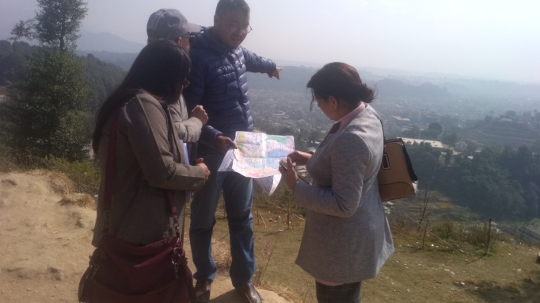 | 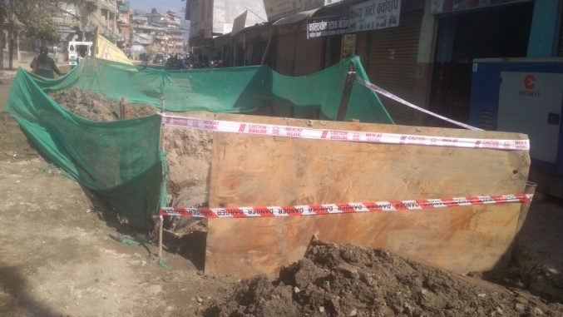
Joint site visit with PID, DSC and CASSC for preparation of TOR for DNI 9 A 1 | Barricade using green nets at Mahankal, however the soil is outside the green nets..
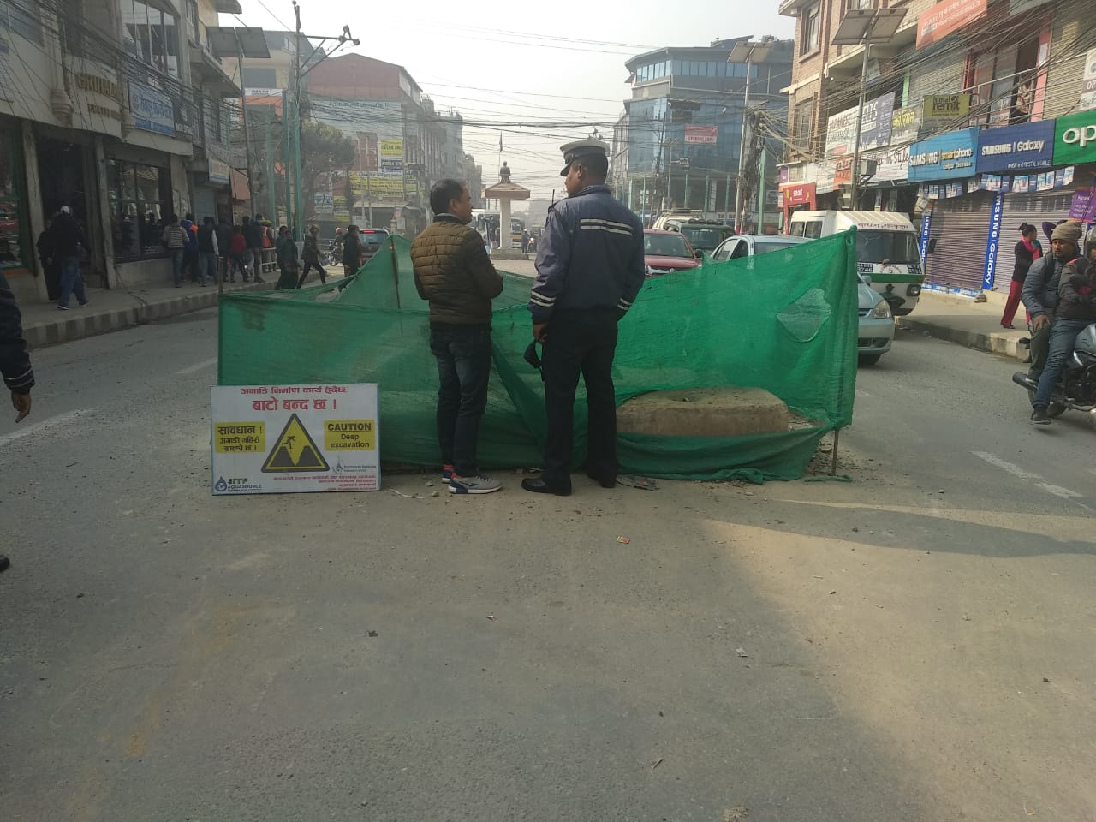 | 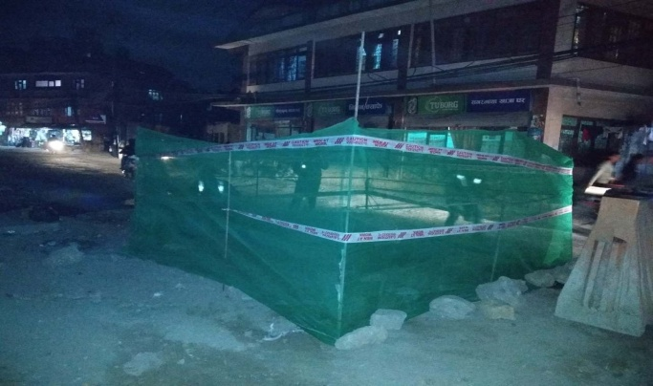
Well barricaded open trench at Narayangopal Chowk. The site although has signage board, it is not as per the standard issued by DSC. | Well barricaded open trench at Chabahil Chowk. However the barricade lacks reflective tape to make it visible at night.
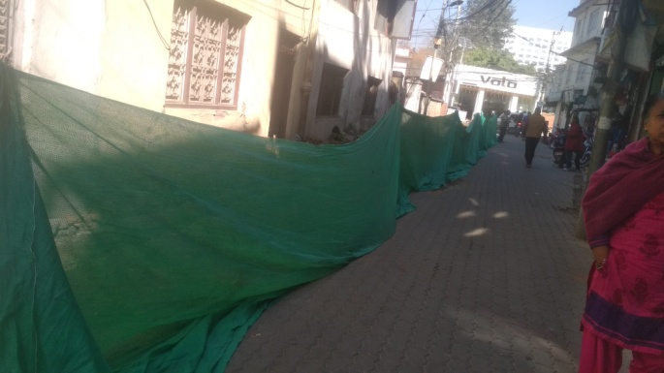 | 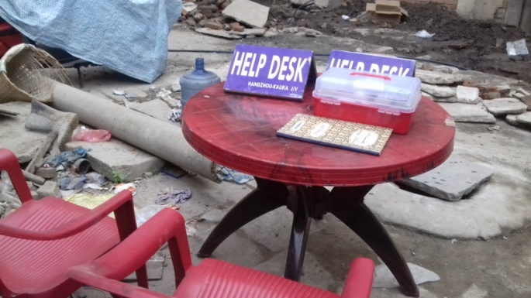
Excavated site barricaded with green nets, to avoid locals from entering the construction site, control dust pollution and maintain the aesthetics at Kamal Pokhari. However the signage boards were placed incorrectly at the site. | Help desk with first aid box and grievance register placed at Basantapur site.
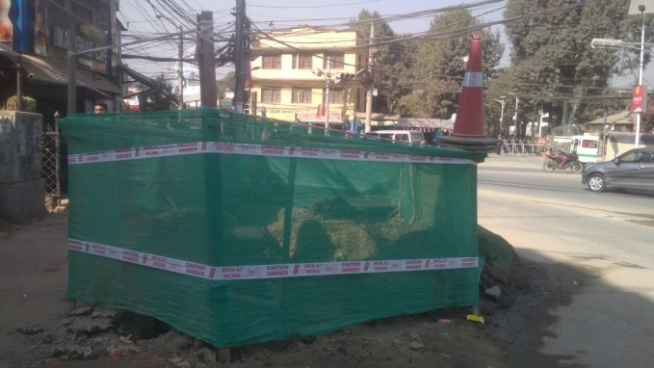 | 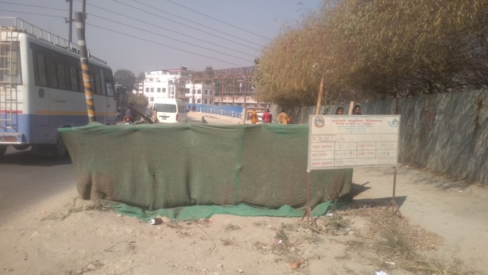
Well barricaded chamber at Maitighar, however the site lacks reflective tape | Barricade using green nets at Bhadrakali along with reflective tape and information board
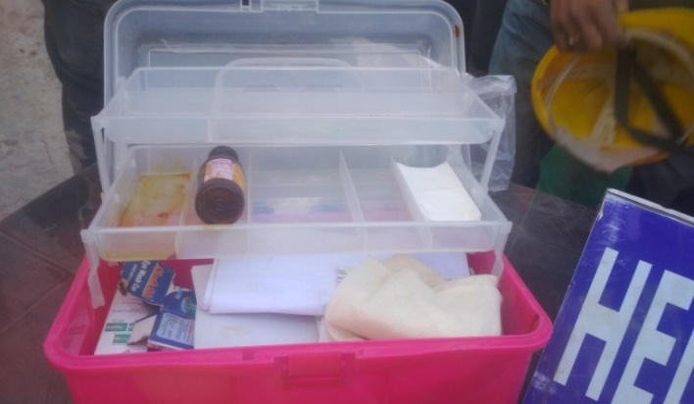 | 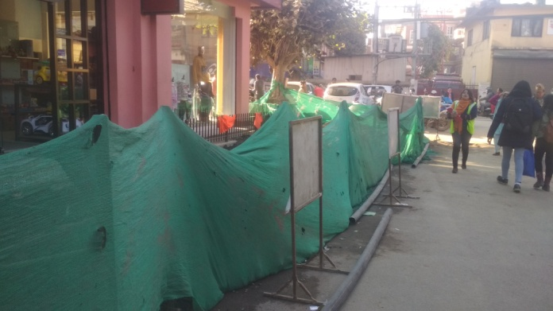
First Aid Box without enough contents at New Road | Barricade of Open trench at New Road. The site is well barricaded with signage boards in place
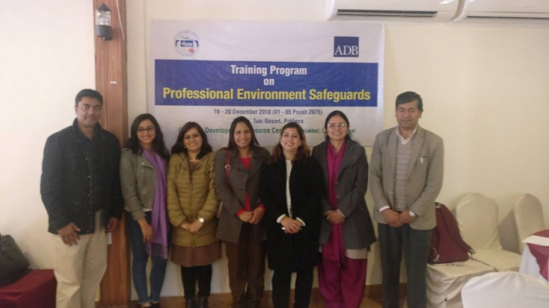 | 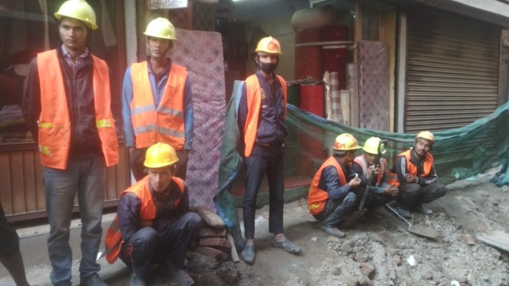
5 day professional Environmental Safeguards training organized by CDRC | Workers with sufficient PPEs at Patan
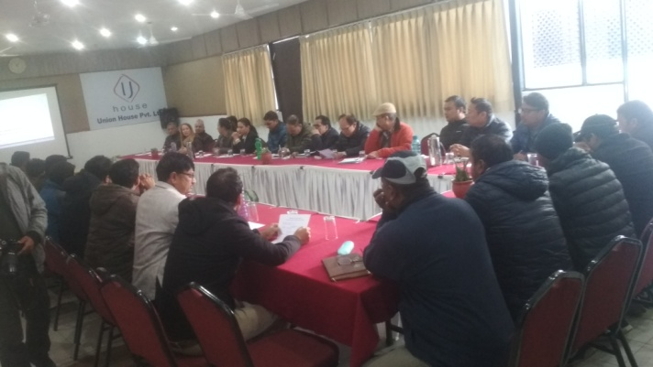 | 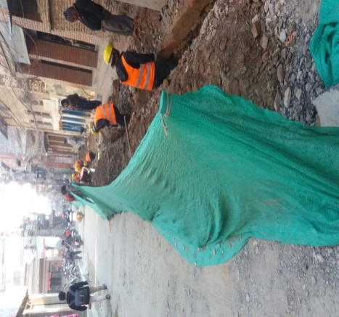
Workshop on Safeguards Compliance in presence of ADB, PID, Consultants (DSC and CASSC) and Contractors | Barricade of Open trench at Gwarko, the workers are seen with sufficient PPEs

II. Letters and Memos
(Available in Hard Copy)

III. OHS Performance Indicator
(Available in Hard Copy)

IV. Grievances Records
(Available in hard copy)

